Lab 09 – IPv6

# What you will do:

* Learn about IPv6 addressing
* Learn to assign static IPv6 addresses
* Learn how IPv6
* Use Wireshark
* Use a router to forward packets between two networks

# Things that you will need to know or learn:

* How to configure IP addresses and subnet masks, both statically and dynamically, using the GUI, under Windows 7/8(see References below)
* How to use Wireshark to see actual network traffic
* How to configure an IPv6 address
* How SLACC and DHCPv6 work to provision IPv6 addresses

# What you need to submit and when:

* Complete the first attempt of the Pre-lab quiz on Blackboard before your scheduled lab period. The remaining attempts need to be completed before end of day October 31, 2014.
* Complete the in-lab part of the exercise (see below) before the end of your lab period.
* Complete the Post-lab exercise on Blackboard before end of day November 5, 2014.

# Required Equipment:

* Network cables, available in lab
* Your laptop
* An IPv6 capable router

# Marks:

* Each of the three lab parts identified above are weighted equally, even though they may have a different number of points assigned to them.
* 20% of your final mark is for labs done during the course of the semester.

# References and Resources:

* Packet Tracer (for help on correct cabling; view of packets similar to Wireshark)
* How IP in Windows 7 (on Blackboard, Labs -> Lab 03)
* How to Wireshark (on Blackboard, Labs -> Lab 03)

How to Cable (on Blackboard, Labs -> Lab 03)Task 0 – **Overview and setup instructions**

1. This lab is to be done individually. It is broken into two parts. In the first part you will use your PC to obtain an IPv6 address from a DHCP server. In the second part you do a Packet Tracer exercise in which you will configure static IPv6 addresses.
2. The two parts of the in-lab exercise are equally weighted.

Task 1 – Laptop obtain IPv6 address - stateless.

1. Disable your Wifi Adpater.
2. Follow **these instructions carefully**. Open the network configuration settings for your Ethernet adapter. Uncheck “Internet Protocol Version 4 (TCP/IPv4)” and check “Internet Protocol Version 6 (TCP/IPv6)”. Click OK to close the dialog window.

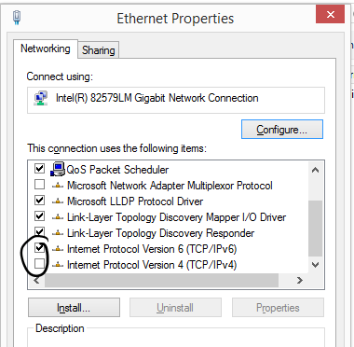

1. Open a windows command prompt and enter the ipconfig /all command. Record your IPv6 settings for your Ethernet adapter. Keep the window open.
2. Start Wireshark, select you Ethernet adapter and start a capture.
3. Now plug an Ethernet cable into your laptop and connect it to one of the “red” network jacks.
4. Run the ipconfig /all command again and record all the IPv6 info for your Ethernet adapter (you might want to capture the screen)
5. Keep checking your IPv6 address information until it changes (you need to keep running the command). It may take several minutes for the address information to change. When the IPv6 address changes, stop and save the capture as “Task1_Step7”
6. Again record the output of the ipconfig /all command. You will need all this information for the post-lab questions.
7. Start a new Wireshark capture and ping the two addresses listed below. The pings MUST be successful
   1. FE80::1
   2. 2001:0:8103:1ab9::1
8. Stop the capture and save it as Task1_Step9
9. Restore you IP settings to what they were before the lab.

**Checkpoint 1 – Open both captures and show them to your instructor**

Task 2 – Packet Tracer Activity

1. Download the file “Lab09 - Configuring IPv6 Addressing.pka”.
2. Complete the activity, ensure you fill in the user profile information as follows:
   1. Name: *First_name Last_name*
   2. E-Mail: *Your algonquinlive email address*

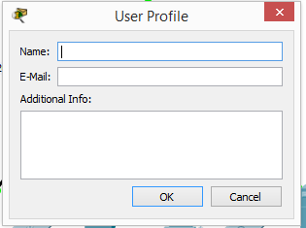

1. Failure to complete the “User Profile” information as stated will result in you receiving “zero” for this activity
2. Complete the Activity. Save it when finished.
3. Upload the completed activity to the Blackboard Dropbox. You can only submit once. Once you have submitted the activity the post-lab quiz will become available.

Checkpoint 2 – This is be awarded at a later date when your Packet Tracer activity has been run through the grading script

Task 3 – Cleanup

1. Restore your Ethernet adapter’s IPv4 and IPv6’s settings to their pre task 0.
2. Return cables to their correct locations
3. Don’t forget to do the post lab, you will need your captures, screen shots, recorded information and your completed Packet Tracer Activity
4. Re-enable wireless